**Spanning Trees**

A spanning tree of an n-vertex [graph](http://mathworld.wolfram.com/Graph.html) is a subset of ***n-1***edges that form a [tree](http://mathworld.wolfram.com/Tree.html).

Consider the 4 vertex graph

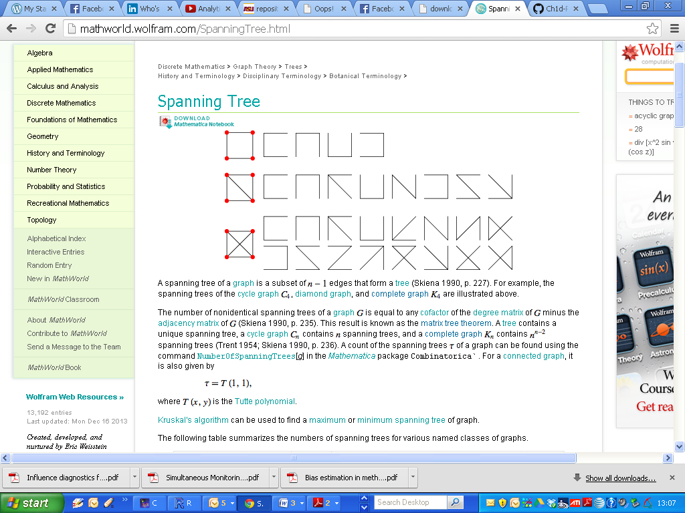

Each of the following are spanning trees of this graph.



**Number of non-isomorphic spanning trees**

The ***matrix tree theorem*** (also called Kirchhoff's matrix-tree theorem) states that the number of non-identical [spanning trees](http://mathworld.wolfram.com/SpanningTree.html) of a [graph](http://mathworld.wolfram.com/Graph.html) **G** is equal to any [cofactor](http://mathworld.wolfram.com/Cofactor.html) of the [degree matrix](http://mathworld.wolfram.com/DegreeMatrix.html) of **G** minus the [adjacency matrix](http://mathworld.wolfram.com/AdjacencyMatrix.html) of **G.**

(Buekenhout and Parker 1998),